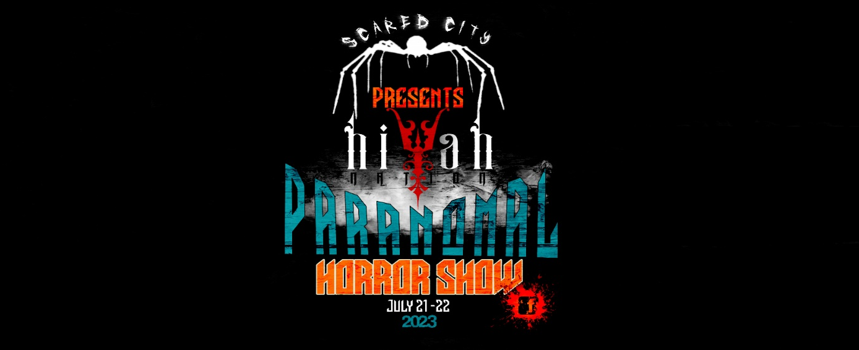

Event Contract
This contract is made effective as of ____________ (date) by and between Scared City Presents HIYAH Paranormal Horror Show and ___________________________________ (VENDORS)
Name of the Booth: __________________________________________________________
Brief description of items to be sold: _______________________________________________________ __________________________________________________________________________________________________________________________________________________________________________
The VENDORS represent that they desire to rent a booth on 7/21/23 – 7/22/23 (date) at the B. C. Lloyd building on the Greene County Fairgrounds in Paragould, AR. Therefore, the parties agree as follows:
- BOOTH RENTAL FEE
  - 10x10 BOOTH $90 – Includes 2 vendor passes, 1 table and 2 chairs

  - 10x20 BOOTH $160 – Includes 3 vendor passes, 1 table and 2 chairs

  - $70 FOR EACH ADDITIONAL BOOTH – no additional tables or chairs

  - Extra Vendor passes $10 each

  - Electricity hook up $10

  - Event T-shirts $20-$25 each

- CANCELLATIONS:
In the event of a VENDOR cancellation, the BOOTH RENTAL IS NON-REFUNDABLE. The rental fee is TRANSFERABLE to future events By Scared City Presents HYAH Nation Paranormal Horror Show. In the event of future event cost increases, the vendor will be responsible for the difference.
- VENUE RESTRICTIONS:
The VENDOR(S) understands that they and their individual guests will abide by the permit requirements while on the property of Greene County Fairgrounds. This includes the following:

- If you wish to move equipment, tables, chairs, etc, you must first get approval from Scared City Presents HIYAH Nation Paranormal Horror Show staff.
- Set up begins at 8 am on 7/21/23.
- All vendor items must be removed by 10:00 pm on 7/22/23.
- ABSOLUTELY NO UNDER-AGE DRINKING

- FOOD & CATERING:
  - Food trucks and concessions will be available. No outside food is allowed.

- LIABILITY:
The vendor cannot hold Scared City Presents HIYAH Nation Paranormal Horror Show, liable for suit, actions, damages, and expenses in connection with personal injury, illness, or property damage or theft resulting from the use of any facility at Greene County Fairgrounds.

- ENTIRE AGREEMENT:
This agreement contains the entire agreement of the parties and there are no other promises or conditions in any other agreement whether oral or written. This agreement supersedes any prior written or oral agreements between the parties.

- AMENDMENT:
This Agreement may be modified or amended if the amendment is made in writing and is signed by both parties.

- RULES AND REGULATIONS:
The following is a list of rules and regulations to be upheld by vendors:

- FOOD: No food outside food allowed. There will be food trucks and concessions available.

- EVENT TIMES:
- Set up may begin at 8 am on 7/21/23.
- Show Hours:
Friday 1:00 pm – 8:00 pm
Saturday 10:00 am – 6:00 pm

- NO OPEN FLAMES OR FIREWORKS PERMITTED. NO SMOKING INSIDE THE BUILDING.

- Decorations: Any decorations that need use of a ladder to install, must be done with
vendor’s own ladder and all liability is on that of the vendor. Staples are not allowed to be used anywhere on the property of Greene County Fairgrounds. All decorations should be removed when leaving the property and done so that no damage is done to the property.

NOTE: FIREWORKS ARE NOT PERMITTED ON THE PROPERTY OF Greene County Fairgrounds.

RENTAL CONTRACT
Event Date _________________

10x10 Booth Rental _________________

10X20 Booth Rental _________________

Addition Booth Space ________________

Electricity Hook up ___________________

Extra Vendor Passes ($10 each) _________

Event T-shirts ($20-$25 each):

Size | Quantity | Total
Small $20
Medium $20
Large $20
X-Large $20
2XL $25
3XL $25
4XL $25
Total T-Shirt Cost:

Total Contract Price: ________________________

Vendors are financially responsible for all the above.

Method of payment:
- Cash
- Paypal: email address: _________________________________
- Cash App: $Cashtag: ___________________________________

_________________ _____ Date:__________
Vendor Signature

___________ ________ _ Date:__________

Scared City Presents HIYAH Nation Paranormal Horror Show

PLEASE FILL OUT THE FORM COMPLETELY AND EMAIL IT TO SCOTTFOXSPIZZA@GMAIL.COM.

IF YOU HAVE AN QUESTIONS OR TO ARRANGE PAYMENT, PLEASE FEEL FREE TO REACH OUT TO SCOTT BANEY AT 870-219-0810.

